Practical Examination
Subject code: PRN232 – SU25
Duration: 85 minutes
Garage FU is a car repair center with many technical staff in charge of service orders for each customer's car. To digitize the entire operation, Garage requires you to build a management system with the following features:
Admin can view, delete all vehicles.
Staff can only see the list of vehicles they are in charge of.
The system needs to support filtering/sorting the vehicle list using OData.
Solution Name: SU25_PRN232
Users table
Column | Data Type | Constraints
UserId | int | Primary Key, Identity (auto-increment)
Email | nvarchar(100) | No duplicates
PasswordHash | varchar(100) | Encrypt (hashed)
Role | Int | Default is 0
Vehicles table
Column | Data Type | Constraints
VehicleId | int | Primary Key, Identity (auto-increment)
PlateNumber | nvarchar(20) | Not null, do not leave blank
Brand | nvarchar(50) | Allow null
OwnerName | nvarchar(100) | Foreign Key Categories(CategoryId)
UserId | int | Foreign Key Users(UserId)
Services table
Column | Data Type | Constraints
ServiceId | int | Primary Key, Identity (auto-increment)
Description | nvarchar(200) | Not null, do not leave blank
Price | decimal | Default is 0
ServiceOrders table
Column | Data Type | Constraints
OrderId | int | Primary Key, Identity (auto-increment)
VehicleId | int | Foreign Key Vehicles (VehicleId)
ServiceId | int | Foreign Key Service(ServiceId)
CreatedAt | datetime | Default is the time of enrollment creation
Status | bit | Default is 1

1. Question 1: Build CRUD API and test with Postman (6 marks)
- Create a database and Entity Framework Core model, can use Code First or Database First. (1 point)
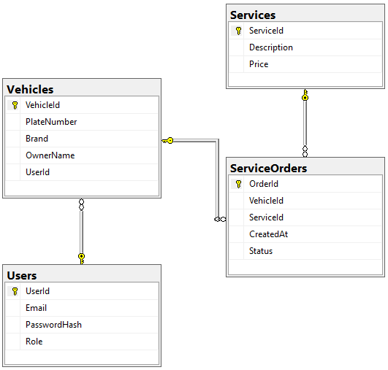
- Implement authentication (1 point):
  - POST /api/auth/login -> receives Email + Password
  - Returns UserId and Role
- Create a CRUD API for the Vehicles table (2 points):
  - POST /api/vehicles -> Create a new vehicle
  - GET /api/vehicles -> Get a list of vehicles
  - GET /api/vehicles/{key} -> Get a vehicle details
  - PUT /api/vehicles/{key} -> Update vehicle information
  - DELETE /api/vehicles/{key} -> Delete a vehicle
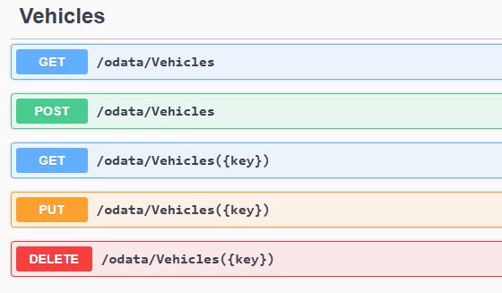
- Integrate OData to support dynamic queries in Vehicles table, including (2 point):
  - Query vehicles with license plates starting with ‘43A’
  - Sort vehicles list by Brand ascending
Note: Test the API using Postman
  - Send POST, GET, PUT, DELETE requests
  - Take a screenshot of each sentence's results using Postman and save it to a Word file (.docx).
2. Question 2: Display API data (ODataController) on Web ASP.NET MVC / Razor Pages (3 marks)
- Create a simple website that displays a list of vehicles from the API:
  - /Login page (1 point)
    - Show a login form with Email + Password
    - Call /api/auth/login
  - /Vehicles page (2 points)
    - Displays a list of vehicles. Requires full display as shown below, including License Plate, Manufacture, Vehicle Owner
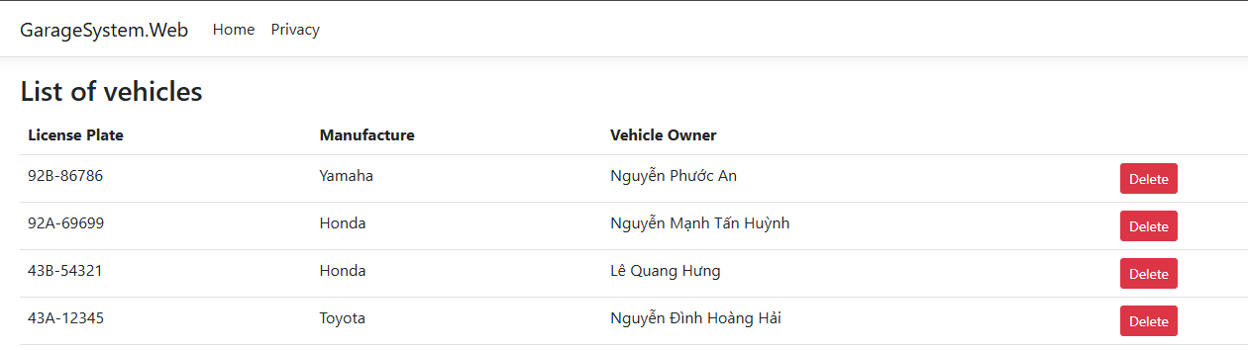
    - Admin:
      - See all vehicles
      - Can delete (show delete button)
    - Staff:
      - Only see their vehicles (UserId match)
      - No delete button shown
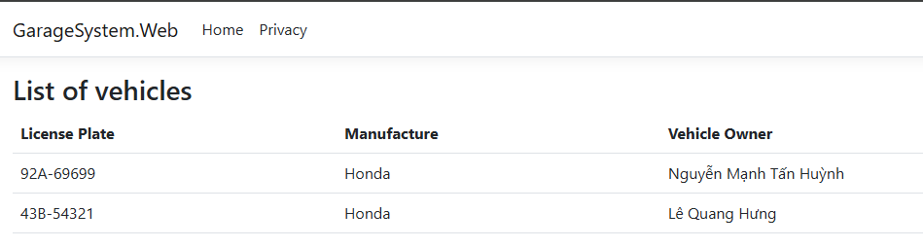
Bonus Points
- Apply Repository Pattern, Service to Organize Code Better (0.5 point)
- Using AutoMapper to Convert Between Entities and DTOs (0.5 point)

Important Notes:
- Functionality Requirement: Your submission must be fully functional. Projects that fail to compile or run will receive a score of zero. Ensure all features are correctly implemented and thoroughly tested before submission.
- Without word file, question 1 will not be graded.

Submission Requirements:
- Submit a all project files, Include a word file.
- Ensure that no personal identifiers (name or student ID) are included in the submission.

Additional Instructions:
- You may use local resources, but internet access is allowed to installing packages via NuGet(in the first 5 minutes).
- Strict adherence to the project structure (Business, DataAccess, Repositories) is required to achieve full marks.

